# Front-End UI/UX Mini Project

## Project Report

### *1. Title Page*

Project Title: Responsive Art Portfolio Website  
Submitted By:

Likhith Vinoy

2460400

likhith.vinoy@btech.christuniversity.in

Aadhin Benny

2460483

[aadhin.benny@btech.christuniversity.in](mailto:aadhin.benny@btech.christuniversity.in)

Basil Baby

2460484

[basil.baby@btech.christuniversity.in](mailto:basil.baby@btech.christuniversity.in)

Course: UI/UX Front End Developement  
Instructor Name: Narendra   
Institution: Christ(Deemed to be University),Kengeri Campus  
Date of Submission: 13/08/2025

### *2. Abstract*

This project is a responsive online art portfolio built entirely using HTML5 and CSS3. The goal is to create a visually appealing platform for showcasing paintings and digital artwork in a gallery format. The website incorporates modern UI/UX principles such as a responsive grid layout, hover animations, and consistent typography. Core technologies include HTML5 for semantic structure and CSS3 for styling, layout, and responsiveness. The final outcome is a clean, engaging, and mobile-friendly website that can be used by artists to display their work in an aesthetically pleasing and easily navigable manner.

### *3. Objectives*

- Design a user-friendly and visually striking art gallery interface.

- Develop a fully responsive layout using HTML5 and CSS3.

- Use semantic HTML structure for better readability and SEO.

- Apply CSS styling for branding, layout, and visual consistency.

- Ensure accessibility and smooth viewing across devices.

### *4. Scope of the Project*

Focused solely on front-end design (no JavaScript or backend).  
Optimized for desktop, tablet, and mobile devices.  
Uses open-source images and hand-written CSS without frameworks.  
Intended for personal portfolio and small business artist websites.

### *5. Tools & Technologies Used*

|  |  |
| --- | --- |
| ***Tool / Technology*** | ***Purpose*** |
| *HTML5* | *Structure & semantic layout* |
| *CSS3* | *Styling, responsiveness, hover effects* |
| *VS Code* | *Code editing* |
| *Chrome DevTools* | *Testing & debugging* |

### *6. HTML Structure Overview*

- Semantic tags used: <header>, <main>, <footer>.  
- Portfolio grid structured with <div> containers for each art card.  
- Navigation menu created using <ul> and <a> tags.  
- Each artwork contains an image, title, and 'View Details' button.

### *7. CSS Styling Strategy*

- External CSS embedded in <style> tag.  
- Uses CSS variables for theme colors.  
- Grid layout for responsive portfolio display.  
- Hover effects for interactivity on art cards and buttons.  
- Media queries for mobile adaptation.  
- Color palette emphasizes gold and dark tones for an elegant look.

### 8. *Key Features*

|  |  |
| --- | --- |
| ***Feature*** | ***Description*** |
| *Responsive Grid Design* | *Adjusts layout based on screen width* |
| *Hover Effects* | *Cards lift and scale images slightly on hover* |
| *Themed Color Palette* | *Gold highlights with dark backgrounds* |
| *Quote Integration* | *Inspirational art quotes in header & footer* |
| *Clean Navigation* | *Simple, centered navigation menu* |

### *9. Challenges Faced & Solutions*

|  |  |
| --- | --- |
| ***Challenge*** | ***Solution*** |
| *Text readability over background images* | *Used background overlay with dark tint* |
| *Maintaining grid responsiveness* | *Implemented auto-fill with minmax() in CSS Grid* |
| *Keeping images proportional* | *Used object-fit: cover for consistent display* |

The project successfully delivers a responsive, aesthetic art portfolio that works seamlessly across devices. It maintains design consistency, focuses on user experience, and highlights artworks effectively.

### *11. Future Enhancements*

- Add JavaScript for filtering artworks by category.

- Include a light/dark theme toggle.

- Integrate backend to allow dynamic image uploads.

- Implement animated transitions between gallery views.

### *12. Screenshots of Final Output*

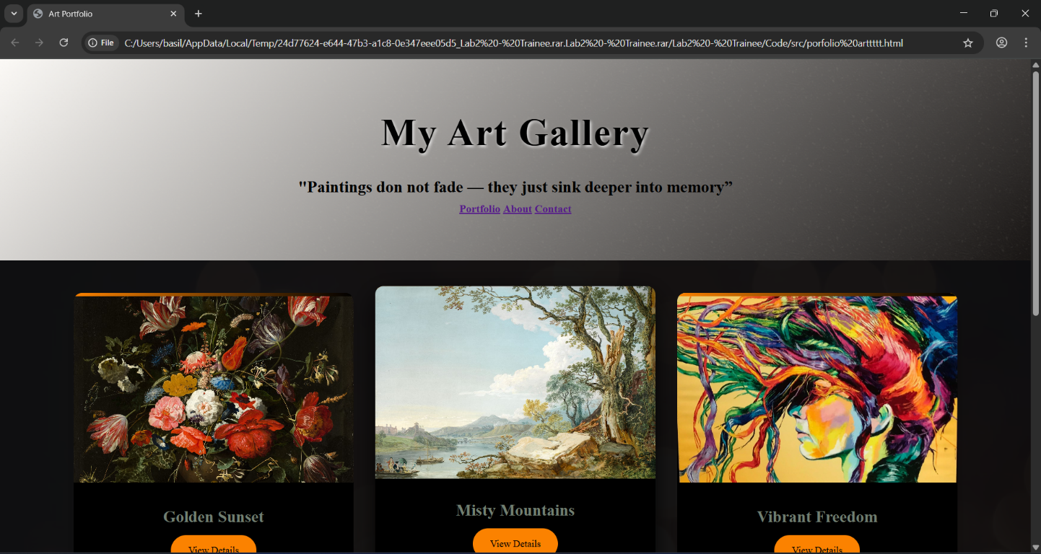

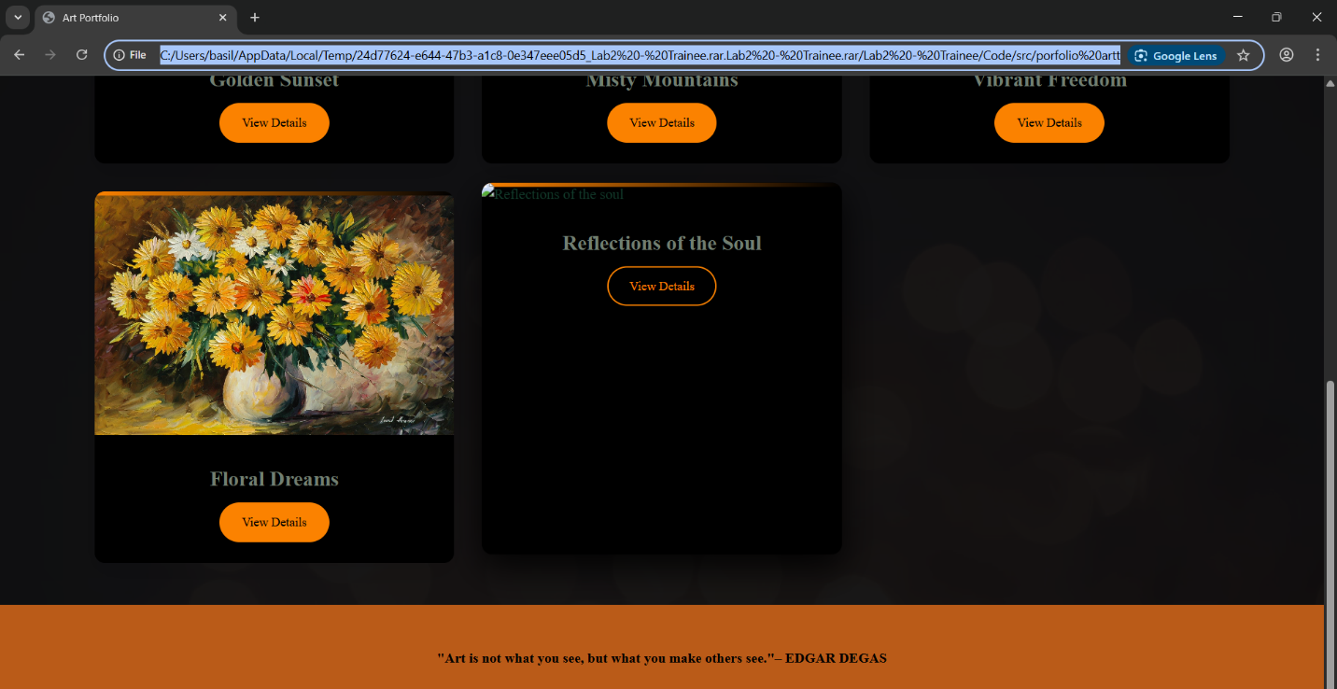

### *13. Conclusion*

This project allowed me to design a visually appealing, mobile-friendly portfolio website for art enthusiasts and creators. I improved my understanding of CSS Grid, color theory, and responsive design principles. The outcome is a functional and elegant platform that can be expanded with interactive features in the future.

### *14. References*

L&T LMS: https://learn.lntedutech.com/Landing/MyCourse  
Unsplash.com – Free stock images  
Transparent Textures – Background patterns